American Towing, Inc. is accepting sealed bids for the following vehicle:

2022 HYUNDAI ELANTRA
VIN# - KMHLS4AG0NU292531
Mileage: 31,899
*KEYS
Minimum Bid $6145.00

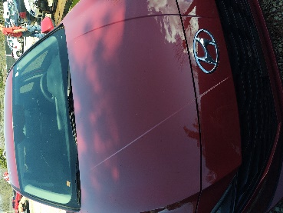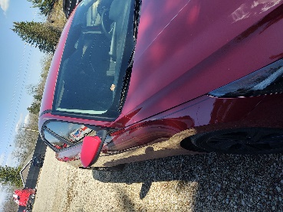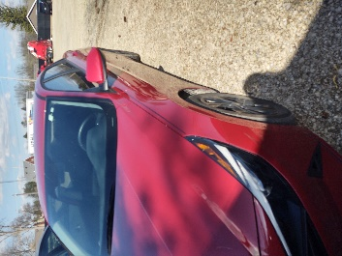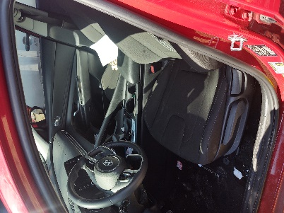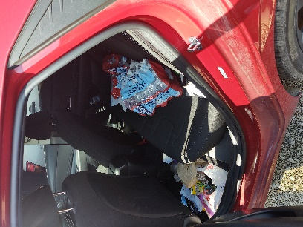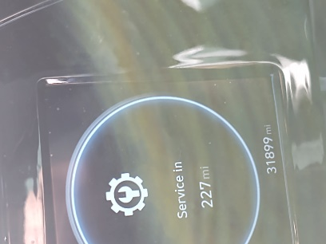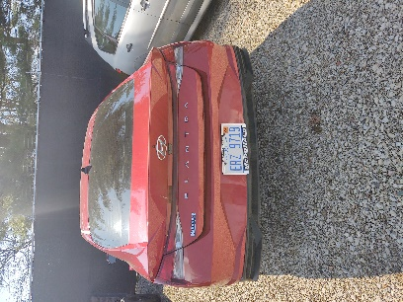

Sealed bids will be accepted until 1:00 p.m. on Friday, April 26, 2024. “Vehicle Bid” should be clearly marked on the outside of bid envelope. The envelope shall contain the American Towing, Inc. vehicle/ equipment bid form. Bid opening will immediately follow.

Winning bidder will be notified by phone and must provide full payment by 1:00 p.m. on Friday, May 03, 2024. Payments by cash or certified cashier’s check only, otherwise vehicle may be sold to next highest bidder.

It is understood that said vehicle is being sold AS IS. Purchaser agrees to indemnify American Towing, Inc. from any claims associated with the use of said vehicle. It is further understood that NO Warranty of any nature in connection with said vehicle is expressed or implied.

